Q1) Write a class with FirstName, LastName & age field. Print Firstname, LastName & age using static block, static method & static variable respectively.

public class Main {

static String *FirstName*,*LastName*;

static int *Age*;

static {

*FirstName* = "Khushwant";

*LastName* = "Prajapati";

*Age* = 23;

}

static void show(){

System.*out*.print("FirstName "+*FirstName*+"\n"+"LastName "+*LastName*+"\n"+"Age "+*Age*);

}

public static void main(String[] args) {

Main.*show*();

}

}

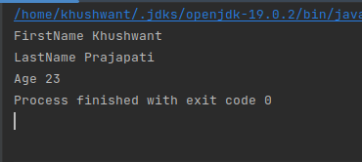

Q2) Write a program to read user input until user writes XDONE and then show the entered text by the user on command line

import java.util.ArrayList;

import java.util.List;

import java.util.Scanner;

public class assignment {

public static void main(String[] args){

List<String> arr = new ArrayList<>();

System.*out*.println("Enter the value and type XDONE to end"+"\n");

Scanner input = new Scanner(System.*in*);

while (true){

String line = input.nextLine();

if("XDONE".equalsIgnoreCase(line)){

break;

}

arr.add(line);

}

System.*out*.print(arr);

}

}

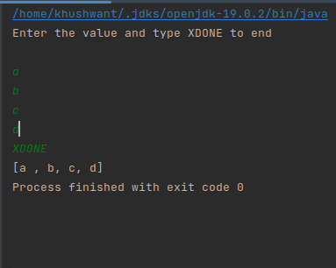

Q3) Write a java program to show following menu to the user:

\*\*\*\*\*\*\*Menu\*\*\*\*\*\*\*

1. Calculate Area of Circle

2. Calculate Circumference of a Circle

3. Exit.

Choose an option (1-3):

Take radius as user input.

Hint: Use Switch statement to act on the menu. Also area and circumference methods should be static

import java.util.\*;

public class assignment {

static double *pi* = 3.14;

public static void main(String[] args){

int option;

double radius,circuference;

Scanner input = new Scanner(System.*in*);

System.*out*.print("\*\*\*\*\*\*\*Menu\*\*\*\*\*\*\*"+"\n"+

"1. Calculate Area of Circle"+"\n"+

"2. Calculate Circumference of a Circle"+"\n"+

"3. Exit."+"\n"+

"Choose an option (1-3): ");

option = input.nextInt();

switch (option)

{

case 1: System.*out*.print("Enter Radius: ");

radius = input.nextDouble();

System.*out*.print("Area of Circle :"+*pi*\*(radius\*radius));

break;

case 2: System.*out*.print("Enter Radius: ");

radius = input.nextDouble();

circuference = Math.*round*(2\**pi*\*radius);

System.*out*.print(circuference);

break;

case 3: System.*out*.print("Exited");

break;

default: System.*out*.print("Invalid Choice");

}

}

}

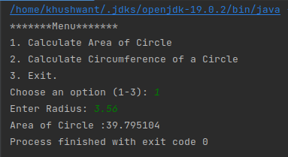

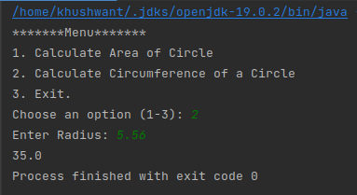

Q4) Create a two dimensional array of integers and display:

* sum of all elements of each column
* sum of all elements of each row

import java.util.\*;

class assignment {

static int *m* = 2, *n* = 2;

static void row(int arr[][]){

int i,j,sum=0;

for(i=0;i<*m*;++i){

for(j=0;j<*n*;++j){

sum += arr[i][j];

}

System.*out*.print("Sum or row "+ sum + "\n");

sum = 0;

}

}

static void column(int arr[][]){

int i,j,sum=0;

for(i=0;i<*m*;++i){

for(j=0;j<*n*;++j){

sum += arr[j][i];

}

System.*out*.print("Sum or column "+ sum + "\n");

sum = 0;

}

}

public static void main(String[] args) {

int i,j;

int[][] arr = new int[*m*][*n*];

Scanner sc = new Scanner(System.*in*);

for(i=0;i<*m*;i++){

System.*out*.print("Enter the value of row "+"\n");

for(j=0;j<*n*;j++)

arr[i][j]=sc.nextInt();

}

*row*(arr); *column*(arr);

}

}

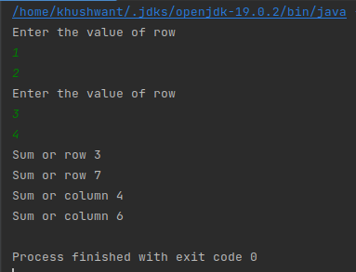

Q5) Create a class named Employee with fields firstname,lastname,age and designation.

The class should:

* have all types of constructors to initialize the object
* class should also have setter methods to update a particular field
* Override its toString method to display a meaningful message using all these fields.

class assignment {

String FirstName = "Khushwant",LastName = "Prajapati",Designation = "Trainee";

int Age = 23;

public assignment(){

}

public assignment(String FirstName,String LastName,String Designation,int Age){

this.FirstName = FirstName;

this.LastName = LastName;

this.Designation = Designation;

this.Age = Age;

}

public String getFirstName() {

return FirstName;

}

public void setFirstName(String firstName) {

FirstName = firstName;

}

public String getLastName() {

return LastName;

}

public void setLastName(String lastName) {

LastName = lastName;

}

public String getDesignation() {

return Designation;

}

public void setDesignation(String designation) {

Designation = designation;

}

public int getAge() {

return Age;

}

public void setAge(int age) {

Age = age;

}

@Override

public String toString() {

return "FirstName = " + FirstName + '\n' +

"LastName = " + LastName + '\n' +

"Designation = " + Designation + '\n' +

"Age = " + Age ;

}

public static void main(String[] args) {

assignment obj = new assignment();

obj.setFirstName("Rahul");

obj.setLastName("Kumar");

obj.setDesignation("Trainee");

obj.setAge(24);

System.*out*.print(obj.toString());

}

}

